2011 New Mexico Open - $10,000
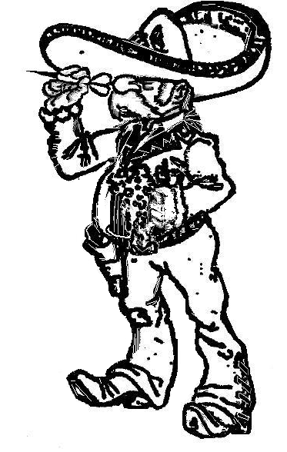
November 11th – 13th, 2011

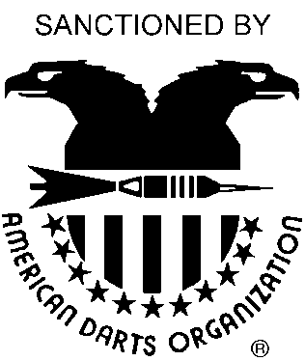
Tournament Location:
Albuquerque Hilton / Fairfield
1901 University Boulevard NE
Albuquerque, New Mexico 87102
Hotel Information:
Hilton: (505) 884-2500 Fairfield: (505) 889-4000
$89 per night $69 per night
Ask for Darters Rates

2011 Cricket Regional
Friday – November 11th
12:00 Noon
For further
Information contact:
Donna Burkeholder
505-255-6372

Sponsored by the New Mexico Dart Association

DATE | FRIDAY | SATURDAY |  |  |  |  |  | SUNDAY
TIME | 8:00 pm | 11:00 am | 11:30 am | 2:00 pm | 2:30 pm | 5:00 pm | 8:00 pm | 11:00 am | 2:00 pm | 2:30 pm
EVENT | BLIND  DRAW  501 | MEN'S  DOUBLES  CRICKET | LADIE'S  DOUBLES  CRICKET | MEN'S  SINGLES  CRICKET | LADIE'S  SINGLES  CRICKET | OPEN  DOUBLES  501 | BLIND  DRAW  PENGUIN# | MIXED  TRIPS  701 | MEN'S  SINGLES  501 | LADIE'S  SINGLES  501
FEE | $15  PERSON | $30  TEAM | $30  TEAM | $20*  PERSON | $20*  PERSON | $30  TEAM | $15  PERSON | $45  TEAM | $20*  PERSON | $20*  PERSON
1ST | $400 | $400 | $200 | $340 | $250 | $400 | $400 | $360 | $340 | $250
2ND | $200 | $200 | $100 | $200 | $130 | $200 | $200 | $180 | $200 | $130
TOP 4 | $100 | $100 | $60 | $100 | $60 | $100 | $100 | $120 | $100 | $60
TOP 8 | $60 | $60 | $30 | $60 | $30 | $60 | $60 | $90 | $60 | $30
TOP 16 | $30 | N/A | N/A | $30 | N/A | N/A | $30 | N/A | $30 | N/A
TOTAL | $1280 | $1040 | $540 | $1220 | $620 | $1040 | $1280 | $1140 | $1220 | $620
ENTRIES CUT-OFF 15 MINUTES PRIOR TO ALL EVENTS *INCLUDES $2 ADO SURCHARGE CASH ONLY!!! NO CHECKS!!!
#Penguin Rules: Game order of 501 , Cricket, then 301 as needed for best 2-out-of-3

Absolutely no outside food or drink allowed.
This flyer available at: http://www.albuquerquedarts.com/2011open.pdf

